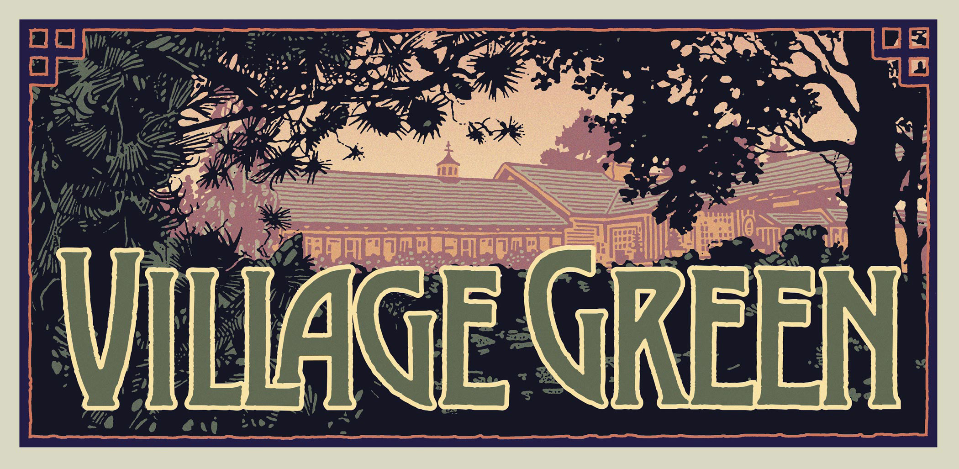
March 2020
Sunday | Monday | Tuesday | Wednesday | Thursday | Friday | Saturday

1  Dave Bock  7-9pm | 2  Matt Puccio Jr  7-9pm | 3  Mark Malefyt  7-9pm | 4  Natty-O  7-9pm | 5  Gregg Biller  7-10pm | 6  Perfect Flavor  9pm-12am | 7  Tatiamo  9pm-12am
8  Dave Bock  7-9pm | 9  Bobby Selover  7-9pm | 10  Bobby Selover  7-9pm | 11  Larry Barkemeyer  7-9pm | 12  Basin Street Band  7-10pm | 13  Tatiamo  9pm-12am | 14  Jesse Boden Band  9pm-12am
15  Bobby Seelover  7-9pm | 16  Bobby Selover  7-9pm | 17  Bobby Selover  7-9pm | 18  Natty-O  7-9pm | 19  Joanne Broh  7-10pm | 20  Chris Baron Band  9pm-12am | 21  Blue Mountaineers  9pm-12am
22  Dave Bock  7-9pm | 23  Elwood  7-9pm | 24  Gary Millard  7-9pm | 25  Larry Barkemeyer  7-9pm | 26  Larry & Tom  7-10pm | 27  Down Home Boys  9pm-12am | 28  Concrete Delta Trio  9pm-12am
29  Dave Bock  7-9pm | 30  Blue  Mountaineers  7-9pm | 31  Dave Bock  7-9pm

